**LABTEST**

**Shihab Muhtasim(21301610)**

**CSE460(2)**

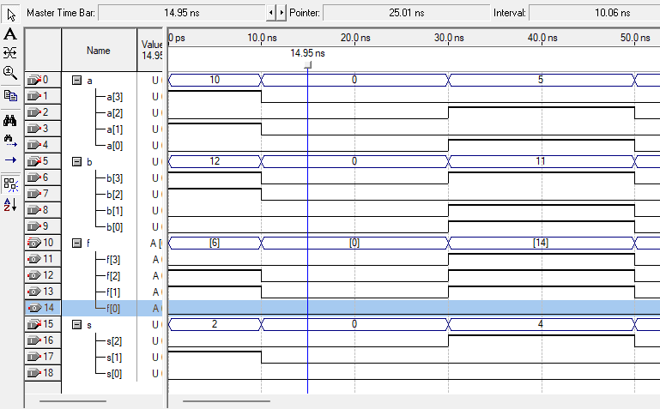

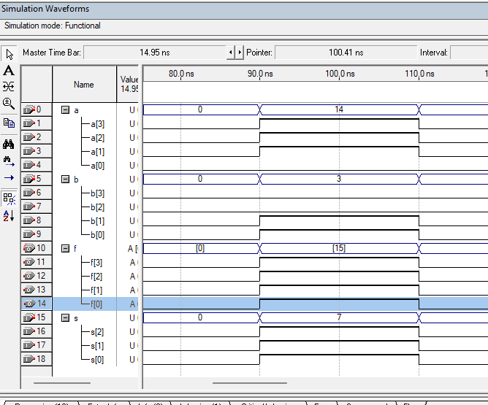

Explanation is in script. But here the f is

**CODE:**  
module testing(a,b,s,f);

input [3:0]a;

input [3:0]b;

input [2:0]s;

output reg [3:0]f;

always @(*)

begin

case(s)

0: f= a&b;

1: f=a|b;

2: f=a^b;

3: f=a^~b;

4: f=~(a&b);

5: f=~(a|b);

endcase

end

endmodule

**TASK 2:**

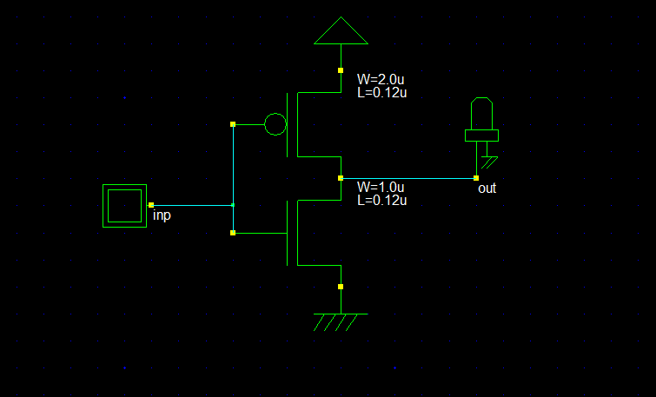

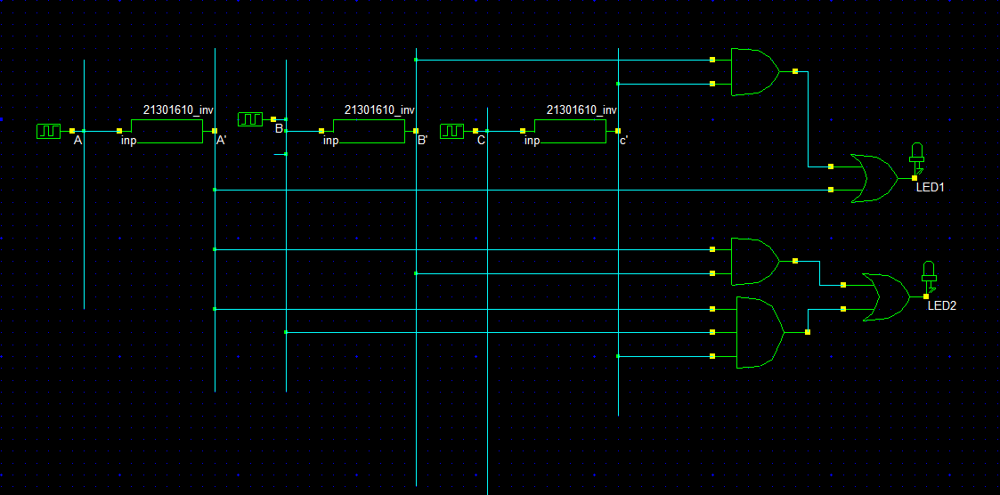

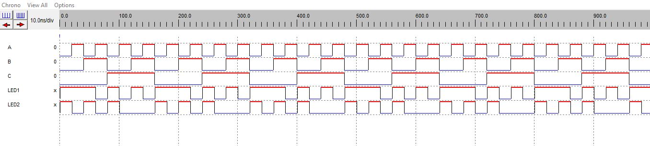

This timing diagram shows the LED outputs for both led 1 and led 2 following the truth table/ conditions. Here the inputs are A,B,Cwhere higher signal means 1 and lower means 0. Also then the output is on both LEDS based on these input combinations. For example if we look at a test case.

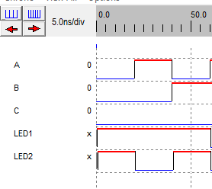

Here the Ais 0, B is 0, C is 0 so both led are on. Then when a is 1 so for 100 te led 2 is off.